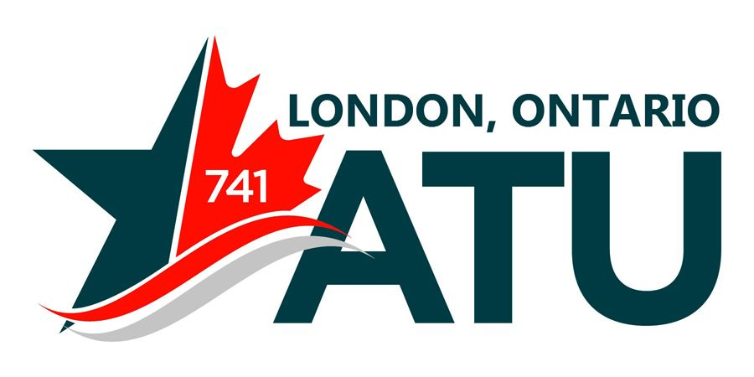

Due to scheduling conflicts with the International Conference our General Members meeting will take place on August 15th, 12:30pm and 6:30pm @ 390 Saskatoon St, Unit 103

